ANNUAL REPORT
2025 – 2026
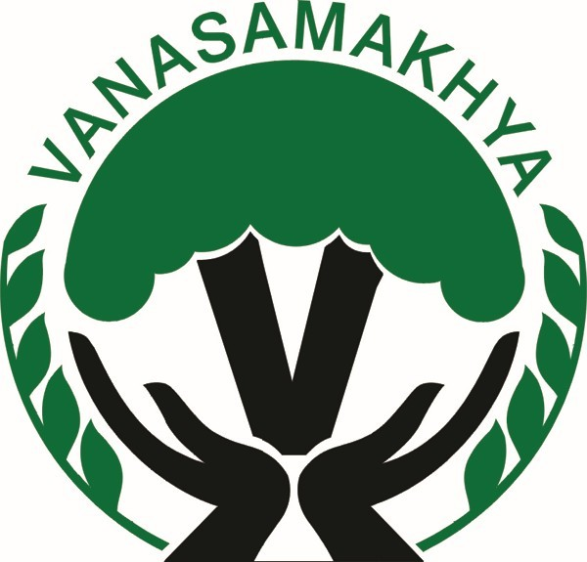
VANASAMAKHYA
Empowering forest-dependent tribal communities through participatory governance and sustainable livelihoods
Financial Year
1 April 2025 – 31 March 2026
H.No. 4-12/29, Street No. 01, Srisai Durganagar, Boduppal, Hyderabad – 500 092, Telangana
Field Office: Pasra, Govindaraopet Mandal, Mulugu District

Table of Contents
1. Executive Summary 3
2. About Vanasamakhya 4
3. Goal 4
4. Objectives 4
5. Operational Area 5
6. Key Achievements (2025–26) 5
6.1 Tribal Development Fund (TDF) – Venkatapuram Project 5
6.2 TDF – Tadvai and Govindaraopet Mandals (Maa Thota) 8
6.3 Medaram Farmer Producer Organisation 9
6.4 Sammakka Sarakka Farmers Producer Company Ltd. (SSFPCL) 10
6.5 Natural Farming Project – Azim Premji Foundation (APF) 11
6.6 Skill Development and Livelihood Enhancement Programme (CRPF) 12
6.7 Results Framework: Targets vs Achievements 13
6.8 Inclusion: Women and Tribal Communities 14
7. Highlights after the Reporting Period (April–October 2026) 14
7.1 NABARD Mango Festival 2026, Hyderabad 14
7.2 Other Developments 15
8. Partnerships and Collaborations 15
9. Challenges, Responses and Learnings 15
10. Way Forward (2026–27) 16
11. Acknowledgements 16
12. Governance, Compliance and Transparency 16
13. Financial Statements 2025–26 17
13.1 Grant Utilisation by Programme 17
13.2 Income and Expenditure Account for the year ended 31.03.2026 18
13.3 Receipts and Payments Account for the period 01.04.2025 to 31.03.2026 18
13.4 Balance Sheet as on 31.03.2026 18
13.5 APF Project – Income and Expenditure Account (2025–26) 19
13.6 Application of Income (Assessment Year 2026–27) 19
Annexure 1: Audited Financial Statements 2025–26 20

1. Executive Summary
The financial year 2025–26 was a year of consolidation and institution-building for Vanasamakhya. Working with tribal and forest-dependent communities of Mulugu district, Telangana, the organisation carried forward NABARD-supported orchard (Maa Thota / Wadi) development, strengthened two farmer producer organisations, supported women-led enterprises, and expanded into natural farming and youth skill development with new partners.
Under the Tribal Development Fund (TDF) – Venkatapuram project, plantation with intercropping was completed in 326 Wadis by 31 March 2026 (181 in Year 1 and 145 in Year 2), supported by water-resource development and 23 livelihood units. In the completed TDF project of Tadvai and Govindaraopet mandals, Vanasamakhya restored orchards damaged by fire and unseasonal storms, introduced Banganapalli top-working (grafting), and completed the Project Completion Report (PCR) verified in the field by NABARD.
Medaram FPO mobilised ₹5.90 lakh in share capital and membership fees from 500 members, obtained GST registration and input-dealer licences, and recorded its first business turnover of ₹2.00 lakh. Sammakka Sarakka FPCL marketed tribal honey, pickles and mangoes through the Medaram Gram Dukan and NABARD-supported stalls in Hyderabad and Warangal, while 120 SHG women trained under LEDP received certificates and stipends and were facilitated for ₹30 lakh of bank credit.
New initiatives included a natural farming project with Azim Premji Foundation in five villages of Govindaraopet mandal and a Skill Development and Livelihood Enhancement Programme with CRPF 39th Battalion that trained 125 tribal youth and women in five trades. The accounts for 2025–26 were audited by M/s Sampath & Ramesh, Chartered Accountants, who issued an unmodified (clean) opinion; total income for the year was ₹40.88 lakh.
Against annual targets, 8 of 12 key indicators were fully achieved; the remaining four (Wadi plantation, livelihood units, share-capital enhancement and women’s credit linkage) are in progress for completion in 2026–27 (Section 6.7). Women made up all 120 LEDP trainees and the 25-member tailoring batch, and about 90% of skill-programme participants were from Scheduled Tribes (Section 6.8).
Key Highlights 2025–26
326  Wadis established under TDF Venkatapuram (by Mar 2026) | ₹14.26 L  Resources mobilised through convergence | 23  Livelihood units grounded (Venkatapuram) | 1,155  Mango plants replanted after fire damage
500  Members mobilised in Medaram FPO | ₹5.90 L  Share capital & fees raised by Medaram FPO | 120  SHG women certified under LEDP (beekeeping) | 125  Tribal youth & women skilled with CRPF

Outreach at a Glance (2025–26)
Programme | Supported by | Direct participants / beneficiaries
TDF – Venkatapuram (Wadi + livelihood units) | NABARD | 500 tribal families (450 Wadi + 50 livelihood) in 10 villages
TDF – Tadvai & Govindaraopet (orchard restoration) | NABARD | 19 fire-affected and 31 storm-affected farmers; 3 orchards top-worked
Medaram FPO | NABARD (TDF) | 500 farmer-members in 14 villages
LEDP – beekeeping (SSFPCL) | NABARD | 120 SHG women in 4 villages
Natural farming project | Azim Premji Foundation | Farmers of 5 villages in 4 Gram Panchayats
Skill development programme | CRPF 39th Battalion | 125 youth and women (25 women in tailoring)
Convergence – kitchen-garden seeds | Horticulture Dept. & ITDA | 100 farmers

2. About Vanasamakhya
Founded in 2002, Vanasamakhya is a collective network of Village Forest Committees (VFCs/VSSs) working within the Joint Forest Management (JFM) framework to support forest-dependent Scheduled Tribe communities. Our mission is to empower communities through participatory forest governance and to promote equitable development, particularly for tribal populations, women and marginalised groups.
Through consistent collaboration with local communities, government agencies and civil-society organisations, Vanasamakhya strives to foster decentralised forest governance, strengthen rural livelihoods and advance sustainable natural resource management. Vanasamakhya is a registered society and serves as the Project Implementing Agency (PIA) for NABARD’s Tribal Development Fund projects in Mulugu district.
Particular | Details
Name of the organisation | Vanasamakhya
Legal status | Registered Society (AOP – Regd. Society)
Year of establishment | 2002
PAN | AABAV4699J
Registered office | H.No. 4-12/29, Street No. 01, Srisai Durganagar, Boduppal, Hyderabad – 500 092
Field office | Pasra, Govindaraopet mandal, Mulugu district, Telangana
Secretary / Chief Functionary | Shri D. Srinivasulu
Treasurer | Shri Ch. Ramulu
Statutory auditor | M/s Sampath & Ramesh, Chartered Accountants (FRN 005947S)

3. Goal
To coordinate forest and livelihood management in forest-dependent communities, promoting sustainability and strengthening Village Forest Committees (VFCs) with equitable participation and self-reliance.

4. Objectives
- Promote active community participation in VFC functioning.
- Ensure representation and leadership opportunities for women, Scheduled Tribes (STs), Scheduled Castes (SCs) and marginalised communities.
- Strengthen VFCs and local Vanasamakhyas through capacity building and cooperation.
- Facilitate dialogue between communities, government and NGOs to resolve issues.
- Enable effective resolution of VFC/EDC and non-VFC-related matters.
- Promote awareness through platforms such as Maa Adavi.
- Collaborate with like-minded organisations to improve forest-dependent livelihoods.

5. Operational Area
Vanasamakhya operates across forest-dependent villages of Mulugu district, Telangana, covering activities that range from natural resource management and orchard development to enterprise promotion and skill building. The programmes implemented during 2025–26 and their coverage are summarised below.
Programme | Supported by | Mandal(s) | Coverage
TDF – Venkatapuram (Wadi development) | NABARD | Venkatapuram | 10 villages, 500 tribal families
TDF – Tadvai & Govindaraopet (Maa Thota) | NABARD | Tadvai, Govindaraopet | Post-project support; PCR completed
Medaram FPO | NABARD (TDF) | Tadvai, Govindaraopet | 14 villages, 500 members
Sammakka Sarakka FPCL | NABARD | Govindaraopet, Tadvai | Marketing, Gram Dukan, LEDP
LEDP – Beekeeping | NABARD | Tadvai, Govindaraopet | 4 villages, 120 SHG women
Natural Farming Project | Azim Premji Foundation | Govindaraopet | 5 villages, 4 Gram Panchayats
Skill Development Programme | CRPF 39th Battalion | Venkatapuram, Wazedu | 125 youth and women

Organisation Structure of Vanasamakhya
Vanasamakhya is a three-tier federation of community forest institutions. Representation is built from the village upwards, and women’s participation is mandatory at every level.  - Vana Samrakshana Samithi (VSS): village-level forest committees, the foundation of the federation.  - Local Vanasamakhya: formed at range, beat or section level by 5–20 VSSs; each VSS sends two representatives (one woman and one man).  - State-level General Body: two representatives from each local Vanasamakhya.  - Executive Committee: nine members elected from the General Body, responsible for governance and oversight. | 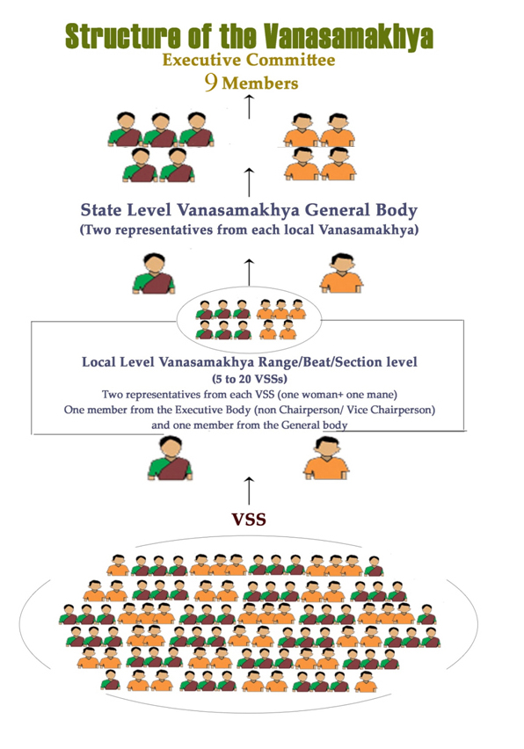  Figure 1: Structure of Vanasamakhya

6. Key Achievements (2025–26)

6.1 Tribal Development Fund (TDF) – Venkatapuram Project
The TDF–Venkatapuram project is being implemented by Vanasamakhya as PIA through the Venkatapuram Mandal Maa Thota Development Committee. The project supports 500 tribal families in 10 villages – 450 families through Wadi (orchard) development and 50 families through livelihood units.

6.1.1 Wadi Development – Progress
A total of 450 Wadis were sanctioned under the project. In the first year (2024–25), 250 Wadis were sanctioned, of which plantation and related activities were completed in 181 Wadis. In the second year (2025–26), a further 200 Wadis were sanctioned; together with the pending Wadis of Year 1, 269 Wadis were taken up for implementation, and activities were completed in 145 Wadis. Thus, by 31 March 2026, plantation with intercropping had been successfully completed in 326 Wadis.
During the current year (2026–27), plantation has been completed in a further 50 Wadis (43 in Nuguru and 7 in Thippapuram), including border plantation, taking the cumulative total to 376 Wadis. Layout marking is in progress for the remaining 74 Wadis, which the PIA plans to complete by the end of October 2026, subject to suitable field conditions and water availability.
Phase | Sanctioned | Taken up | Completed | Cumulative
Year 1 (2024–25) | 250 | 250 | 181 | 181
Year 2 (2025–26) | 200 | 269 | 145 | 326
Year 3 (2026–27, to date) | – | 124 | 50 | 376
Balance to be completed |  |  | 74 | 450

Village-wise Wadi and Livelihood Status (as on March 2026)
S.No | Village | Gram Panchayat | Wadi families | Year 1 | Year 2 | Year 3* | Total Wadis | Balance | LH families | Total families
1 | Yakannagudem | Edira | 33 | 30 | 3 | – | 33 | 0 | 5 | 38
2 | Suraveedu | Suraveedu | 9 | 0 | 4 | – | 4 | 5 | 2 | 11
3 | Sri Rangapur | Suraveedu | 16 | 16 | 0 | – | 16 | 0 | 2 | 18
4 | K. Kondapur | Suraveedu | 58 | 0 | 49 | – | 49 | 9 | 4 | 62
5 | Thippapuram | Thippapuram | 110 | 68 | 26 | 7 | 101 | 9 | 5 | 115
6 | Mutharam | Alubaka | 19 | 0 | 14 | – | 14 | 5 | 7 | 26
7 | Abbayigudem | Morrivanigudem | 58 | 0 | 35 | – | 35 | 23 | 6 | 64
8 | Pathrapuram | Pathrapuram | 26 | 17 | 0 | – | 17 | 9 | 5 | 31
9 | Rachapalli | Rachapalli | 64 | 50 | 14 | – | 64 | 0 | 8 | 72
10 | Nuguru | Nuguru | 57 | 0 | 0 | 43 | 43 | 14 | 6 | 63
 | Total |  | 450 | 181 | 145 | 50 | 376 | 74 | 50 | 500

* Year 3 plantation (50 Wadis) was completed during April–October 2026 and is shown for completeness.

6.1.2 Distribution of Planting Material
Quality grafted mango and guava saplings, along with teak saplings for border plantation, were distributed to Wadi farmers. Across the 376 Wadis established so far, 50,230 saplings have been supplied.
S.No | Village | Wadis | Mango | Guava | Border Teak | Total
1 | Yakannagudem | 33 | 1,848 | 726 | 2,310 | 4,884
2 | Suraveedu | 4 | 224 | 88 | 280 | 592
3 | Sri Rangapur | 16 | 896 | 352 | 1,120 | 2,368
4 | K. Kondapur | 49 | 2,576 | 1,078 | 3,430 | 7,084
5 | Thippapuram | 101 | 5,656 | 2,222 | 1,820 | 9,698
6 | Mutharam | 14 | 784 | 308 | 980 | 2,072
7 | Abbayigudem | 35 | 1,960 | 770 | 2,450 | 5,180
8 | Pathrapuram | 17 | 952 | 374 | 1,190 | 2,516
9 | Rachapalli | 64 | 3,584 | 1,408 | 4,480 | 9,472
10 | Nuguru | 43 | 2,408 | 946 | 3,010 | 6,364
 | Total | 376 | 20,888 | 8,272 | 21,070 | 50,230

Note: Includes planting material for the 43 Nuguru Wadis planted in 2026–27. Within 2025–26, 326 Wadis were established.

6.1.3 Water Resource Development (WRD)
Assured irrigation is critical for sapling survival in the first three years. The following water-resource assets were created in the project villages:
S.No | Water resource component | Achievement
1 | Bore wells / open wells with submersible pump set, cable and starter | 16 units
2 | Open wells with oil engine and pump set | 8 units
3 | Mono-block motor pump sets with cable and starter | 6 units
4 | Pipeline (running metres) distributed across all 9 project villages | 18,975 RMT
5 | Water troughs constructed in Wadis | 338 units

6.1.4 Livelihood Units for Landless / Non-Wadi Families
To diversify incomes for families not covered under Wadis, 24 livelihood units were sanctioned and released. By 31 March 2026, 23 units had been grounded; one mini rice-mill unit at Mutharam is pending.
Type of livelihood unit | Units grounded
Buffalo rearing (1 milch animal per family) | 5
Goat / sheep rearing (6+1 unit) | 3
Kirana-cum-vegetable shop | 3
Mini rice mill | 2
Flour mill | 3
Xerox centre | 2
Tailoring (ladies emporium) | 5
Total (against 24 released; 1 mini rice mill pending at Mutharam) | 23

6.1.5 Convergence with Government Schemes and Other Agencies
Scheme / Agency | Activity | Amount (₹)
MGNREGS | Soil and Moisture Conservation (SMC) works in Abbayigudem and Rachapalli villages | 2,88,000
Horticulture Department & ITDA (Maa Thota) | Kitchen-garden seed kits distributed to 100 farmers | 95,000
CRPF 39th Battalion | Skill Development and Livelihood Enhancement Programme for 125 tribal youth (see Section 6.6) | 10,43,000
Total convergence mobilised |  | 14,26,000

6.1.6 Case Study: Bringing Forest Rights Land into Cultivation – Abbayigudem
From idle land to orchards
The Maa Thota farmers of Abbayigudem received about 25 acres of land under the Forest Rights Act, 2006. The land was covered with rocks and thorny bushes and had remained unused. Through MGNREGS convergence, the bushes and rocks were cleared and the land was developed; fruit saplings were then planted under the NABARD-supported Maa Thota programme. Farm ponds are now being constructed in these fields to harvest rainwater, improve groundwater recharge and secure water for the young orchards. The initiative has turned previously idle FRA land into productive orchards and opened a pathway for long-term income for tribal families.

6.2 TDF – Tadvai and Govindaraopet Mandals (Maa Thota)
The TDF project in Tadvai and Govindaraopet mandals has completed its implementation period. During 2025–26, Vanasamakhya focused on protecting and restoring the established mango orchards, improving varietal quality, and completing project closure formalities with NABARD.

6.2.1 Summer Water Supply to Orchards
High temperatures and declining water availability during summer threatened the survival of young mango plants. The farmers jointly decided to arrange water supply, and with their voluntary financial contribution, water was supplied by tractor-tankers to water-stressed orchards during April and May, prioritising the most critical plots. Vanasamakhya provided field-level coordination and guidance. The effort protected plant survival and demonstrated strong farmer ownership of the orchards.

6.2.2 Restoration of Fire-Damaged Orchards
A fire in late March damaged orchards in three villages, completely burning 1,115 mango plants across 19 acres. Damage was assessed in the field and a report was submitted to NABARD. With NABARD support, 1,155 mango saplings were provided to the 19 affected farmers, together with 40 kg neem cake, 38 kg organic manure and 1 litre neem oil per farmer. Farmers were trained on replanting, plant care and plant protection.
Mandal | Village | Area affected (acres)
Govindaraopet | Bussapur | 1
Tadvai | Oddugudem | 14
Tadvai | Pochapur | 4
Total | 3 villages | 19

6.2.3 Support after Unseasonal Rains and Gales
Unseasonal rain and strong winds in April broke 140 mango trees belonging to 31 farmers across 31 acres in eight villages. After field verification, a damage report was submitted to NABARD and each affected farmer received 40 kg neem cake, 38 kg organic manure and 1 litre neem oil, along with advice on plant protection and orchard management to reduce future losses.
Mandal | Villages (acres affected) | Total acres
Govindaraopet | Bussapur (1), Rangapur (2), Karlapalli (4) | 7
Tadvai | Narlapur (4), Bandala (8), Oddugudem (4), Narsapur (5), Bollepalli (3) | 24
Total | 8 villages | 31 farmers | 140 trees | 31

6.2.4 Top-working (Grafting) to Banganapalli Variety
To improve orchard productivity and market value, a top-working programme was taken up to convert low-value Konda Mamidi and Totapuri trees to the high-demand Banganapalli variety. In August, the technical team of Mahalakshmi Nursery, Rajahmundry (led by Shri Subba Rao) surveyed selected orchards and prepared the trees by heading back the branches; grafting was completed in September. The approach upgrades existing trees without uprooting them and is expected to improve fruit quality and prices.
Mandal | Village | Orchard area (acres) | Plants grafted
Govindaraopet | Bussapur | 4 | 50
Tadvai | Narsapur | 9 | 80
Tadvai | L.B. Nagar | 10 | 50
Total |  | 23 | 180

6.2.5 Project Completion Report (PCR) and NABARD Field Verification
All documents, reports, field data and records required for the Project Completion Report were compiled and submitted to NABARD in April. On 20 May 2025, Shri Nidhin (NABARD Regional Office, Hyderabad) and Shri Chandrasekhar (DDM, Warangal) conducted a field verification, visiting Bussapur, Rangapur, Oddugudem, Medaram and Narlapur. The officials interacted with farmers, reviewed orchard development and plant condition, and examined survey data, files, bills and records at the project office. The PCR verification process was completed successfully.

6.2.6 Financial Systems, Livestock Insurance and Record Management
- TDF bank account and CKYC: As the CKYC number for the existing Canara Bank TDF account was unavailable, a new TDF account was opened at Telangana Grameena Bank (TGB), Pasra Nagaram branch, and the CKYC number was obtained, ensuring orderly fund management.
- Livestock insurance: Buffaloes of one livelihood unit each at Rangapur and Chalvai were insured with The New India Assurance Co. Ltd., providing financial security to the livestock owners.
- Records: Project files, bills, farmer data, damage assessments and field reports were updated, filed section-wise and secured at the Pasra field office for monitoring and future reference by NABARD.

6.3 Medaram Farmer Producer Organisation
Medaram FPO (Medaram Farmers Producers and Producers Mutually Aided Cooperative Society) was promoted under the TDF project to give the 500 Maa Thota farmers of Phase 2 a collective platform for input supply, aggregation and marketing. 2025–26 was its first full year of operations.

6.3.1 Institutional Strengthening
- Bank account: A joint bank account in the name of the FPO was opened at TGB, Pasra Nagaram branch, in the first week of April 2025 in the presence of the President Shri Chela Prabhakar, Secretary Smt. Allem Soujanya and CEO Shri Ramesh.
- Member awareness: Awareness meetings were held in 14 villages – Bussapur, Chalvai, Rangapur, L.B. Nagar and Karlapalli (Govindaraopet) and Oddugudem, Pochapur, Bandala, Narsapur, Bollepalli, Narlapur, Kalvapalli, Kannepalli and Medaram (Tadvai) – on the purpose of the FPO, member rights and duties, share capital, and the benefits of collective aggregation and marketing.
- GST registration: The application was filed in October 2025 and the GST certificate was received on 18 December 2025 (GSTIN: 36AAXAM5730D1ZB).
- Input licences: Applications for fertiliser, pesticide and seed sales licences were submitted in March 2026 and the licences were received in April 2026, enabling the FPO to supply quality inputs to members.

6.3.2 Share Capital Mobilisation
Receipts were issued to all members and the amounts were deposited in the FPO’s TGB account by May 2025. Subsequently, on NABARD’s advice, the share value was raised from ₹1,000 to ₹2,000 per member; following awareness meetings in all 14 villages, 40 members contributed an additional ₹1,000 each.
S.No | Particulars | Per member (₹) | Members | Amount (₹)
1 | Share capital | 1,000 | 500 | 5,00,000
2 | Membership fee | 100 | 500 | 50,000
3 | Additional share capital (enhancement to ₹2,000) | 1,000 | 40 | 40,000
 | Total mobilised |  |  | 5,90,000

6.3.3 First Business Turnover – Fruit Marketing
The FPO aggregated and collectively marketed fruit from the Maa Thota orchards of Tadvai and Govindaraopet mandals, reducing the need for individual farmers to search for buyers. Fruit marketing undertaken in March generated a turnover of ₹2,00,000 – an important first step in building the FPO’s business experience and market linkages.

6.4 Sammakka Sarakka Farmers Producer Company Ltd. (SSFPCL)
SSFPCL, formed by the Phase 1 Maa Thota farmers of Govindaraopet mandal, continued to promote tribal products and women’s enterprises.

6.4.1 Marketing of Tribal Products
Natural forest honey, pickles and other tribal products made by tribal women and families are sold through the Gram Dukan (village shop) at Medaram, giving producers a regular outlet and building market recognition for tribal products. With NABARD support, the FPO also set up Honey Stalls and Mango Stalls and organised mango festivals to sell Maa Thota mangoes directly to consumers.
S.No | Venue | Dates | Products sold
1 | HITEC City, Hyderabad | 02–04 September 2025 | Natural honey, pickles, tribal products
2 | Ameerpet, Hyderabad | 08–15 October 2025 | Tribal products
3 | Warangal | 10–23 November 2025 | Natural honey, pickles, mangoes

6.4.2 Income from Godown Rent
The FPO’s godown at Fruit Farm village, Govindaraopet mandal, was rented out, generating additional income for the company. Rent of ₹40,000 was received in four instalments and deposited in the FPO bank account.
S.No | Date | Amount (₹)
1 | 11-07-2025 | 10,000
2 | 15-07-2025 | 10,000
3 | 03-01-2026 | 10,000
4 | 02-02-2026 | 10,000
 | Total | 40,000

6.4.3 LEDP – Beekeeping and Honey Collection
Under NABARD’s Livelihood and Enterprise Development Programme (LEDP), 120 SHG women from four villages were trained in scientific beekeeping and natural honey collection. During the year, the following follow-up actions were completed:
S.No | Mandal | Village | Women trained
1 | Tadvai | Oddugudem | 37
2 | Tadvai | Bollepalli | 30
3 | Govindaraopet | Tappamancha | 36
4 | Govindaraopet | Project Nagar | 17
 | Total | 4 villages | 120

- Certification: Certificates signed and sealed by Shri Ravi, DDM, NABARD, were distributed to all 120 trained women.
- Stipend: A stipend of ₹350 per participant (₹42,000 in total) was transferred directly to the women’s bank accounts, with complete documentation.
- Credit linkage: With support from Shri Nageswar Rao, IKP APM, Govindaraopet, 50 SHG women of Project Nagar and Tappamancha were facilitated for bank loans totalling ₹30 lakh; details of eligible women were submitted to NABARD.
- Second tranche: An application for release of the second tranche of ₹5,50,240 was prepared and submitted to NABARD.

6.5 Natural Farming Project – Azim Premji Foundation (APF)
In partnership with Azim Premji Foundation, Vanasamakhya launched a project to enhance the income of small and marginal farmers, primarily from ST and SC communities, by reducing cultivation costs for paddy, cotton and maize through improved farming practices, and to ensure that eligible families access welfare entitlements. The project covers five villages in four Gram Panchayats of Govindaraopet mandal: Rangapuram, Sandragudem, Balajinagar, Karlapalli and Lakshmipuram. A grant of ₹14.24 lakh was received during the year.

6.5.1 Awareness Programmes
In January and February 2026, awareness programmes were held in all five villages on the objectives of the project and the benefits of natural farming – gradually reducing chemical fertilisers and pesticides, low-cost cultivation, improving soil health, and protecting the environment. Farmers were also informed about government welfare and agriculture schemes and encouraged to apply for their entitlements.

6.5.2 Baseline Survey
A baseline survey was completed across the project villages, covering current crops and practices, cultivation costs, awareness of natural farming, land holdings, forest rights titles (RoFR/IFR) and access to welfare schemes. The baseline provides the foundation for planning trainings, tailoring field activities to farmers’ needs and linking eligible farmers with government schemes.

6.6 Skill Development and Livelihood Enhancement Programme (CRPF)
With the support of the CRPF 39th Battalion under its Civic Action Programme, Vanasamakhya implemented a month-long skill development programme in Venkatapuram and Wazedu mandals from 30 December 2025 to 31 January 2026. The programme addressed unemployment, under-employment and distress migration among youth and women in these remote tribal mandals.
125 unemployed and under-employed men and women were trained in five market-relevant trades. About 90% of participants were from Scheduled Tribe communities and the rest from SC and BC households; around 70% had completed secondary education and 30% were graduates. Training combined projector-based theory, digital learning platforms, intensive hands-on practice and field exposure, followed by theory and practical examinations.
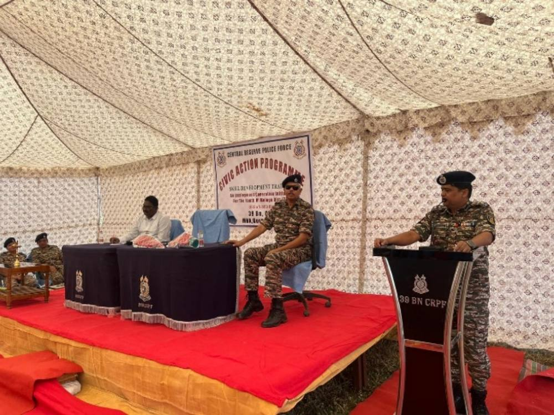  Programme inauguration with CRPF | 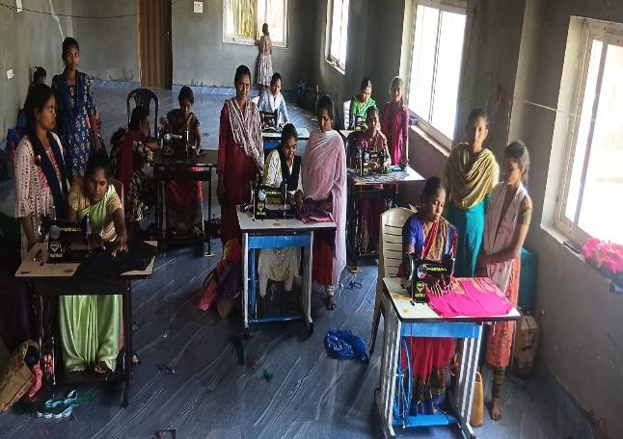  Tailoring training for women | 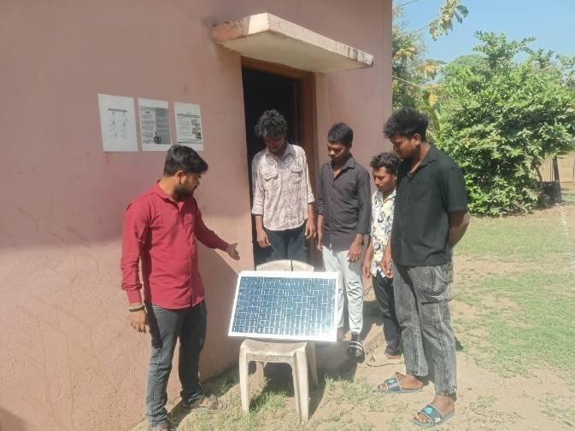  Solar installation practical

S.No | Trade | Participants | Key skills acquired
1 | Electrician | 25 | Domestic and small commercial wiring, fixtures, testing tools, fault diagnosis, safety
2 | Solar Installation Technician | 25 | Panel mounting, inverter wiring, commissioning, troubleshooting, maintenance
3 | Computer Repairing | 25 | Assembly, OS installation, software troubleshooting, basic networking
4 | Mobile Repairing | 25 | Hardware diagnostics, component replacement, software issues
5 | Tailoring (women only) | 25 | Measurement, cutting, stitching, finishing; design exposure via digital platforms
 | Total | 125

Outcomes
- All 125 participants completed the training with negligible drop-outs; three outstanding performers were identified and all participants were recognised with certificates and prizes at a ceremony with CRPF officers.
- Participants are equipped for local service work and self-employment (repair counters, wiring and solar services, home-based tailoring), reducing dependence on seasonal labour and migration.
- The programme strengthened trust between communities and CRPF through visible, development-oriented engagement.

Case Study: Tailoring Skill Leading to Recognition and Livelihood Security
Manikumari, a widow from Tekulagudem village in Wazedu mandal on the far border of Telangana, supported two children from a small rain-fed farm. She joined the tailoring batch, mastered measurement, cutting and finishing on modern machines, and won the 3rd prize for performance. She now has a home-based tailoring skill that offers a steady, year-round income alongside farming.

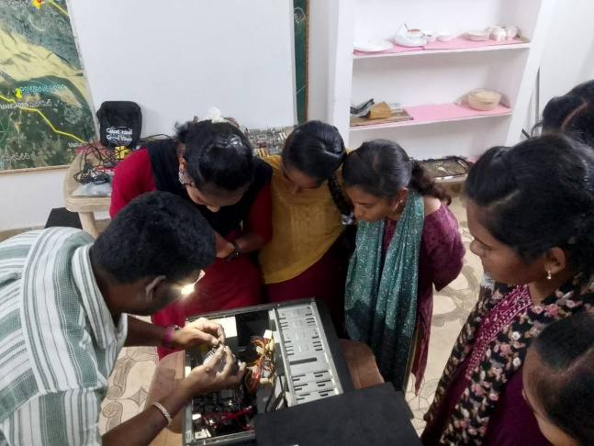  Computer repairing session | 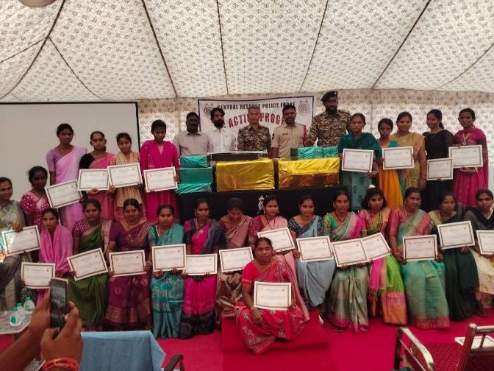  Certificates – women trainees | 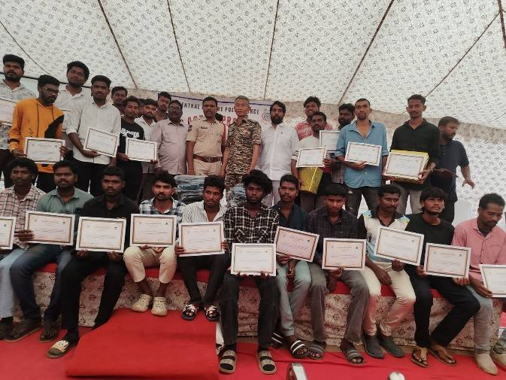  Certificates – youth trainees

6.7 Results Framework: Targets vs Achievements
The table below compares key results with programme targets as on 31 March 2026, using project records and audited accounts.
Programme | Indicator | Target | Achieved | Status
TDF – Venkatapuram | Wadis established with intercropping | 450 | 326 | 72% – on track*
TDF – Venkatapuram | Livelihood units grounded | 24 | 23 | 96%
TDF – Venkatapuram | Families covered (Wadi + livelihood) | 500 | 500 | 100%
TDF – Tadvai & Govindaraopet | Fire-damaged mango plants replaced | 1,115 | 1,155 | 104%
TDF – Tadvai & Govindaraopet | Storm-affected farmers supported with inputs | 31 | 31 | 100%
TDF – Tadvai & Govindaraopet | Project Completion Report submitted and verified | 1 | 1 | 100%
Medaram FPO | Farmer-members enrolled with share capital | 500 | 500 | 100%
Medaram FPO | Share capital at ₹2,000 per member (₹) | 10,00,000 | 5,40,000 | 54% – in progress
Medaram FPO | Statutory registrations (GST + 3 input licences) | 4 | 4 | 100%**
LEDP (SSFPCL) | SHG women trained and certified in beekeeping | 120 | 120 | 100%
LEDP (SSFPCL) | Women credit-linked (₹30 lakh) | 50 | 50 proposals submitted | In process
CRPF skill programme | Youth and women trained and certified | 125 | 125 | 100%

* Reached 376 Wadis (84%) by October 2026; the balance 74 are scheduled for completion by end-October 2026. ** Input licences received in April 2026.
Outcomes Observed
- Better prices through collective marketing: direct sales by the FPOs fetched 40–100% above farm-gate prices for mango, and Medaram FPO recorded its first turnover of ₹2,00,000.
- Stronger community institutions: Medaram FPO now has ₹5.90 lakh of member-owned capital, its own bank account, GST registration and input licences. Sammakka Sarakka FPCL earned ₹40,000 from its godown.
- Leverage of donor funds: ₹14.26 lakh was mobilised through MGNREGS, ITDA, the Horticulture Department and CRPF, about ₹0.96 for every ₹1 of NABARD grant received for the Venkatapuram project during the year.
- Asset protection: orchard losses from fire and storms were restored within the same season, and farmers paid for summer water tankers themselves, a sign that they take ownership of their orchards.
- Access to finance for women: 120 trained women received ₹42,000 in stipends through direct bank transfer, and bank loan proposals of ₹30 lakh were prepared for 50 women.

6.8 Inclusion: Women and Tribal Communities
All programmes target Scheduled Tribe and other marginalised households in forest-fringe villages of Mulugu district. Women’s participation and leadership are built into Vanasamakhya’s structure: each Vana Samrakshana Samithi (VSS) sends one woman and one man to the local Vanasamakhya.
Group | Reach in 2025–26 | Programme
Tribal families (Wadi and livelihood) | 500 families | TDF – Venkatapuram
Tribal farmer-members | 500 members | Medaram FPO
SHG women trained in beekeeping | 120 women | LEDP (SSFPCL)
SHG women facilitated for bank credit | 50 women (₹30 lakh) | LEDP / IKP
Women trained in tailoring | 25 women | CRPF skill programme
Scheduled Tribe trainees | About 90% of 125 trainees | CRPF skill programme
Women in FPO leadership | Secretary, Medaram FPO (Smt. Allem Soujanya) | Medaram FPO

7. Highlights after the Reporting Period (April–October 2026)

7.1 NABARD Mango Festival 2026, Hyderabad
On 22–23 May 2026, NABARD and Vanasamakhya jointly organised the NABARD Mango Festival in Hyderabad. On Day 1 stalls were set up at the NABARD Telangana Regional Office, Reserve Bank of India, TG CAB and Union Bank of India; on Day 2 at the NABARD and RBI staff quarters. The festival was inaugurated by Shri B. Uday Bhaskar, Chief General Manager, NABARD Telangana RO, with senior officers of NABARD. Members of Sammakka Sarakka FPO managed all stalls – display, weighing, packing, digital payments and sales.
1,830 kg  Organic mango sold (5 varieties) | ₹1,88,700  Total sales in two days | 618  Customers served | 88%  Payments received digitally

Variety / product | Quantity | Sale price | Farm-gate price | Value (₹)
Banganapalli | 850 kg | ₹70/kg | ₹50/kg | 59,500
Chinna Rasalu | 600 kg | ₹100/kg | ₹60/kg | 60,000
Totapuri | 180 kg | ₹60/kg | ₹30/kg | 10,800
Pedda Rasalu (Desi) | 100 kg | ₹100/kg | ₹50/kg | 10,000
Pickle local mangoes | 100 kg | ₹100/kg | ₹50/kg | 10,000
Sub-total – Mango | 1,830 kg |  |  | 1,50,300
Forest honey, pickles and mahua flower | 51 kg |  |  | 38,400
Grand total | 1,881 kg |  |  | 1,88,700

Farmers realised a premium of 40–100% over farm-gate prices, an estimated ₹58,000–70,000 of additional income in two days, and the event generated enquiries for institutional bulk orders in future seasons.

7.2 Other Developments
- Plantation completed in a further 50 Wadis under TDF–Venkatapuram (43 in Nuguru, 7 in Thippapuram), taking the total to 376 of 450; the balance 74 Wadis are scheduled for completion by October 2026.
- Medaram FPO received fertiliser, pesticide and seed sales licences in April 2026.
- Statutory audit for 2025–26 completed on 16 September 2026 with an unmodified opinion.

8. Partnerships and Collaborations
Partner | Area of collaboration
NABARD | TDF (Venkatapuram; Tadvai & Govindaraopet), FPO promotion, LEDP, marketing stalls and Mango Festival
Azim Premji Foundation (APF) | Natural farming and access to entitlements – Govindaraopet mandal
CRPF 39th Battalion | Skill Development and Livelihood Enhancement Programme
MGNREGS, ITDA & Horticulture Department | Soil and moisture conservation, land development, kitchen-garden seeds
Telangana Grameena Bank & IKP (SERP) | Bank accounts for TDF and Medaram FPO; SHG credit linkage
The New India Assurance Co. Ltd. | Livestock insurance
Mahalakshmi Nursery, Rajahmundry | Technical support for Banganapalli grafting
Gram Panchayats, VDCs, SHGs and FPOs | Community mobilisation and implementation support

9. Challenges, Responses and Learnings
Challenge | Response by Vanasamakhya
Forest fire (March) burnt 1,115 mango plants on 19 acres | Damage assessed and reported to NABARD; 1,155 saplings, neem cake, organic manure and neem oil supplied to 19 farmers
Unseasonal rain and gales (April) broke 140 trees of 31 farmers | Field verification; plant-protection inputs and orchard-management advice to all affected farmers
Summer water scarcity threatened young plants | Farmers organised and paid for tractor-tanker water supply; Vanasamakhya coordinated
Delays in Wadi plantation at Venkatapuram (field conditions, water) | Water-resource assets created; 50 more Wadis planted by October 2026 and layout marking under way for the remaining 74
Low business volume and working capital in new FPOs | Share capital raised to ₹2,000 per member; GST registration and input licences obtained; direct marketing channels opened
Limited access to skill training in remote border mandals | Partnership with CRPF 39th Battalion to deliver on-site training in five trades

Learnings
- Farmers’ voluntary contribution for summer watering shows growing ownership of the orchards.
- Quick damage assessment and timely donor support helped restore orchards with minimal loss of time.
- Top-working to Banganapalli is a cost-effective way to raise the market value of existing trees.
- Direct institutional marketing (stalls, festivals) fetches significantly better prices than farm-gate sales.
- Convergence with MGNREGS, ITDA and other agencies multiplies the impact of donor investments.

10. Way Forward (2026–27)
- Complete plantation in the remaining 74 Wadis under TDF–Venkatapuram and ensure high sapling survival through WRD and gap filling.
- Ground the pending mini rice-mill unit and provide handholding to all livelihood units.
- Strengthen Maa Thota management – irrigation, plant protection, fire lines and extension of Banganapalli grafting.
- Expand Medaram FPO’s input business and fruit aggregation; increase share capital to ₹2,000 per member.
- Scale up SSFPCL marketing – Gram Dukan, institutional sales and annual Mango Festival with NABARD.
- Complete credit linkage for LEDP-trained women and utilise the second tranche for beekeeping enterprises.
- Roll out natural farming trainings and demonstration plots under the APF project.
- Provide post-training follow-up and market linkage for CRPF-trained youth and women.

11. Acknowledgements
We extend our sincere gratitude to NABARD – the Chief General Manager and officers of the Telangana Regional Office and the District Development Managers – for their sustained support and guidance. We thank Azim Premji Foundation, CRPF 39th Battalion, ITDA, the Horticulture and Agriculture Departments, MGNREGS, Telangana Grameena Bank, IKP, Gram Panchayats, SHGs, VDCs and both FPOs for their valuable cooperation.
Most importantly, we acknowledge the tribal communities of Mulugu district, whose active participation, resilience and trust remain the foundation of Vanasamakhya’s journey.

12. Governance, Compliance and Transparency
Vanasamakhya maintains separate books and bank accounts for each funded project and makes its records available for donor monitoring. Key compliance actions during the year were:
Area | Status during 2025–26
Statutory audit | Accounts for FY 2025–26 audited by M/s Sampath & Ramesh, Chartered Accountants; unmodified (clean) opinion dated 16.09.2026
Income tax | Return computation for AY 2026–27 prepared; income applied to objects and accumulated under Section 11 – taxable income NIL
Project-wise bank accounts | Separate accounts maintained: Axis Bank (APF project), TGB Venkatapuram and SBI Govindaraopet (TDF PIA accounts), SBI Lalaguda (main account and fixed deposit)
Banking KYC | New TDF account opened at TGB, Pasra Nagaram, and CKYC number obtained
Donor verification | NABARD field verification of the TDF (Tadvai & Govindaraopet) Project Completion Report on 20.05.2025
Community institutions | Medaram FPO: bank account, GST registration (36AAXAM5730D1ZB) and input-dealer licences obtained; member receipts issued for all share capital
Records management | Project files, bills, beneficiary data and field reports updated and secured at the Pasra field office

13. Financial Statements 2025–26
The accounts of Vanasamakhya for the year ended 31 March 2026 were audited by M/s Sampath & Ramesh, Chartered Accountants (FRN 005947S). In the auditor’s opinion, the financial statements give a true and fair view of the state of affairs of the Society as at 31 March 2026, of the excess of income over expenditure, and of the receipts and payments for the year (report dated 16.09.2026; Partner CA Jyotsana R, M.No. 232625; UDIN 26232625ARIMYH8994). The audited statements are summarised below and reproduced in full in Annexure 1.

13.1 Grant Utilisation by Programme
Programme / source | Received in 2025–26 (₹) | Spent in 2025–26 (₹) | Utilisation
NABARD – TDF Venkatapuram project | 14,81,900 | 12,04,158 | 81%
Azim Premji Foundation – natural farming (started Jan 2026) | 14,24,000 | 2,60,482 | 18%
CRPF 39th Battalion – skill development | 10,43,550 | 10,22,650 | 98%
LEDP and other trainings | – | 1,08,553 | –
Medaram FPO (advance received) | 93,995 | – | –
Bank interest / bank charges | 45,031 | 468 | –
Total | 40,88,476 | 25,96,311 | 64%

Unspent balances (APF ₹11.70 lakh; TDF Venkatapuram balance held in the PIA account) are carried forward for programme activities in 2026–27.
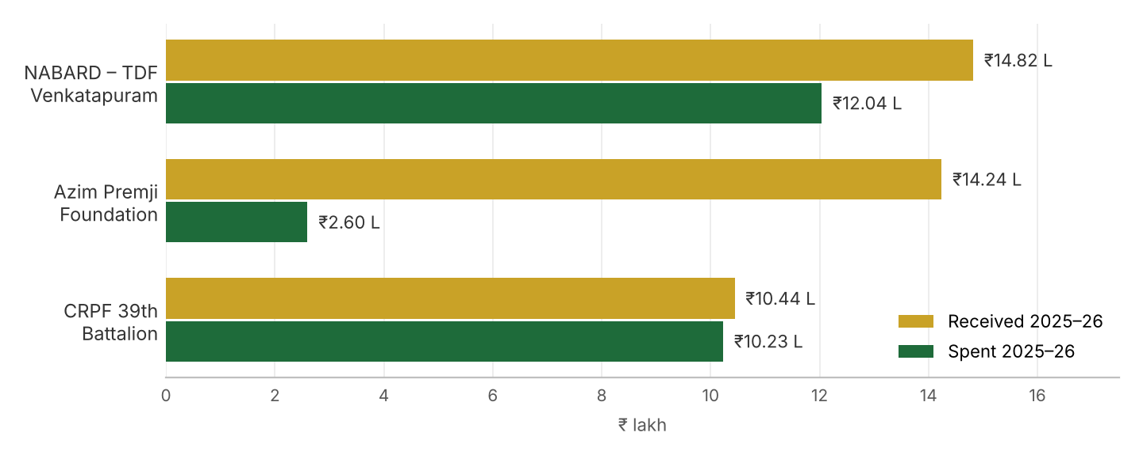
Figure 2: Grants received and spent by programme, 2025–26 (₹ lakh)

13.2 Income and Expenditure Account for the year ended 31.03.2026
Expenditure | Amount (₹) | Income | Amount (₹)
APF project expenditure | 2,60,482 | Grants from NABARD | 14,81,900
TDF project expenditure – Venkatapuram | 12,04,158 | Grant from APF | 14,24,000
CRPF trainings | 10,22,650 | CRPF trainings | 10,43,550
LEDP and other trainings | 1,08,553 | Medaram FPO | 93,995
Bank charges | 468 | Bank interest | 45,031
Excess of income over expenditure | 14,92,165
Total | 40,88,476 | Total | 40,88,476

13.3 Receipts and Payments Account for the period 01.04.2025 to 31.03.2026
Receipts | Amount (₹) | Payments | Amount (₹)
Opening balance |  | APF project expenditure | 2,50,563
Cash at SBI Lalaguda branch | 5,15,794 | TDF project expenditure – VP project | 11,93,130
Cash at SBI Govindaraopet (PIA) | 5,375 | CRPF trainings | 10,22,650
Cash at TGB Venkatapuram (PIA) | 2,12,855 | LEDP programme | 1,08,553
Fixed deposit with SBI Lalaguda | 2,89,667 | Bank charges | 468
Receipts |  | Previous year payables | 1,61,152
Grants from NABARD – V. Puram project | 14,81,900 | Closing balance
CRPF training programme | 10,43,550 | Cash at Axis Bank – APF | 11,79,593
Grants from APF | 14,24,000 | Cash at SBI Lalaguda branch | 30,047
Advance – Medaram FPO | 93,995 | Cash at SBI Govindaraopet (PIA) | 5,375
Advance received from Suresh | 20,000 | Cash at TGB Venkatapuram (PIA) | 8,66,990
Bank interest from banks | 38,875 | Fixed deposit with SBI Lalaguda | 3,13,646
APF bank interest | 6,156
Total | 51,32,167 | Total | 51,32,167

13.4 Balance Sheet as on 31.03.2026
Liabilities | Amount (₹) | Assets | Amount (₹)
General reserve | 9,40,949 | TDS receivable | 3,500
Add: Excess of income over expenditure | 14,92,165 | Advance to staff | 54,910
Total reserves | 24,33,114 | Cash at Axis Bank – APF | 11,79,593
Outstanding payables – TDS payable | 20,947 | Cash at SBI Lalaguda branch | 30,047
 |  | Cash at SBI Govindaraopet (PIA) | 5,375
 |  | Cash at TGB Venkatapuram (PIA) | 8,66,990
 |  | Fixed deposit with SBI Lalaguda | 3,13,646
Total | 24,54,061 | Total | 24,54,061

13.5 APF Project – Income and Expenditure Account (2025–26)
Expenditure | Amount (₹) | Income | Amount (₹)
Salaries | 1,47,429 | Grant from APPI | 14,24,000
Administration cost | 21,988 | Bank interest | 6,156
Travel, boarding and lodging | 10,565
Capital cost | 70,500
Programme cost | 10,000
Excess of income over expenditure | 11,69,674
Total | 14,30,156 | Total | 14,30,156

13.6 Application of Income (Assessment Year 2026–27)
Particulars | Amount (₹)
Gross voluntary contributions and income received | 40,88,476
Less: 15% of contributions (permissible accumulation) | 6,13,271
Amount to be applied to the objects of the Society | 34,75,205
Income applied – revenue expenditure (net of outstanding payables) | 25,75,364
Amount deemed applied – option under Explanation to Sec. 11(1), clause (2) | 8,99,841
Total taxable income | NIL

Note: Figures are as per the audited financial statements. The excess of income over expenditure largely represents unspent grant balances of ongoing projects (APF and TDF–Venkatapuram) carried forward for use in 2026–27.
For Vanasamakhya
D. Srinivasulu  Secretary & Chief Functionary | Ch. Ramulu  Treasurer | Place: Hyderabad  Date: ____________

Annexure 1: Audited Financial Statements 2025–26
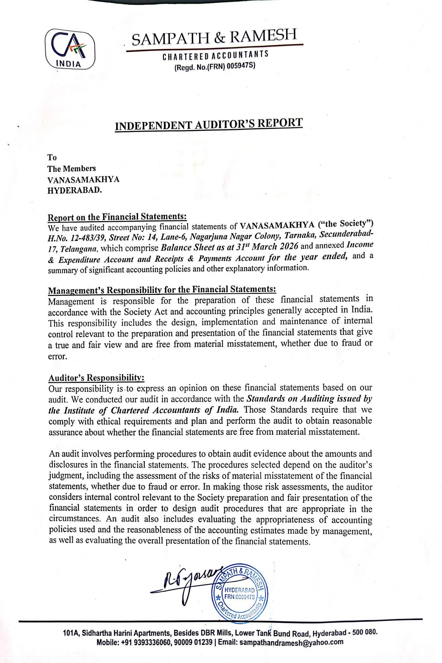
Independent Auditor’s Report (page 1)

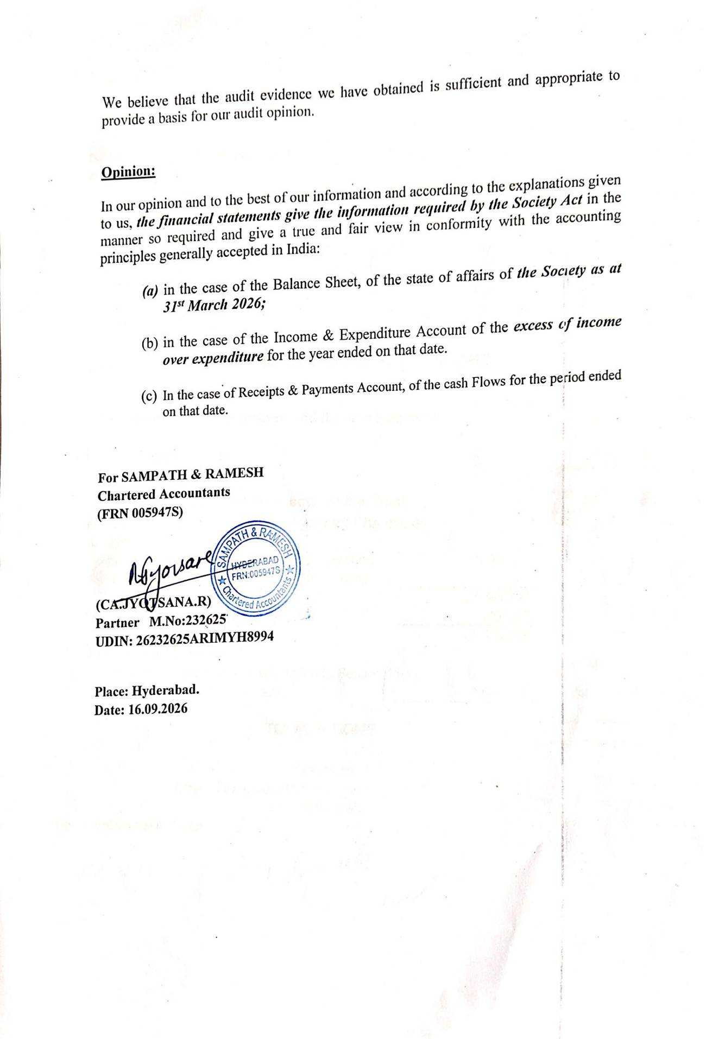
Independent Auditor’s Report – Opinion (page 2)

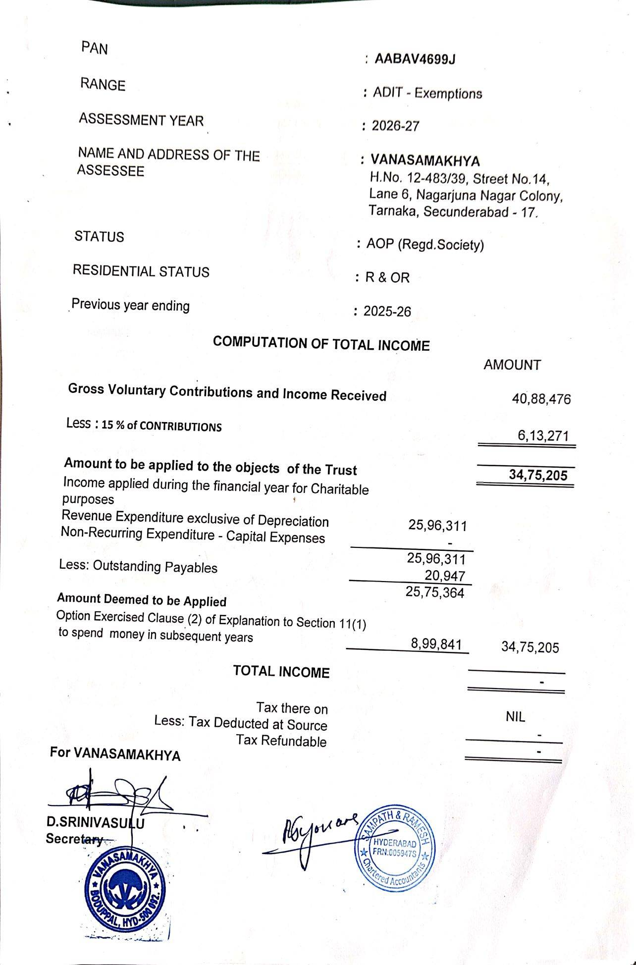
Computation of Total Income – AY 2026–27

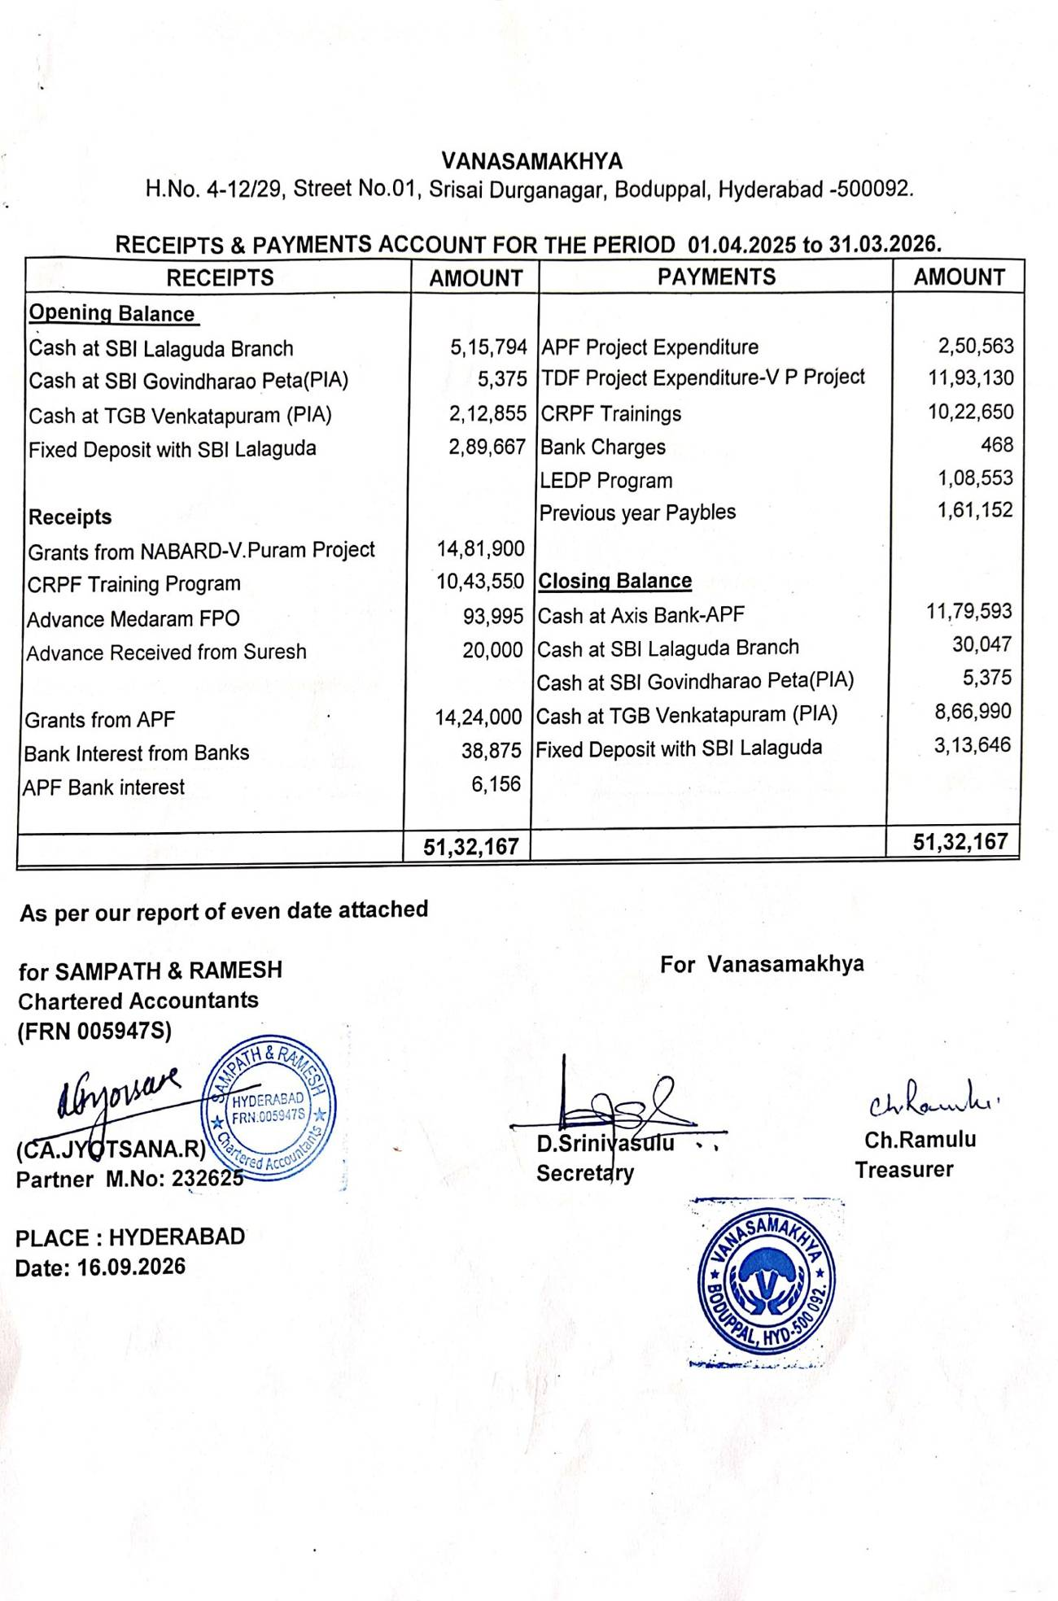
Receipts & Payments Account 2025–26

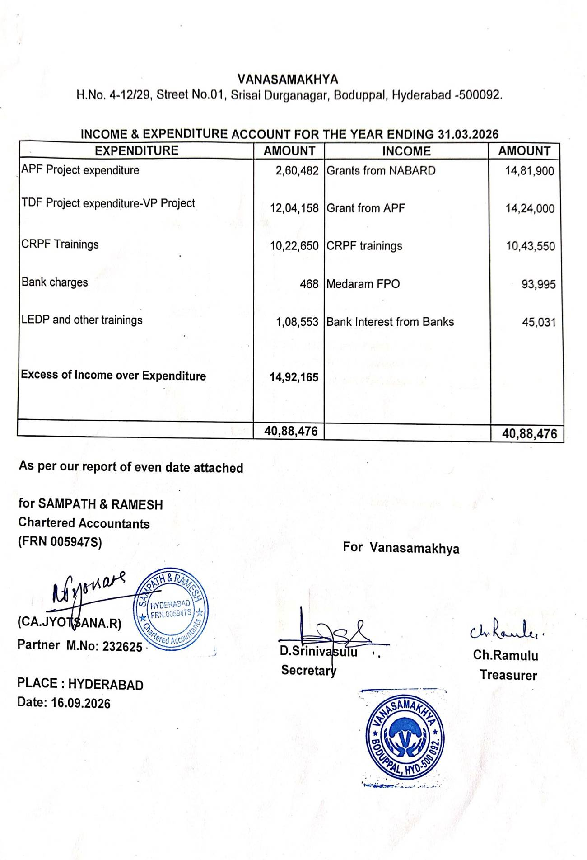
Income & Expenditure Account 2025–26

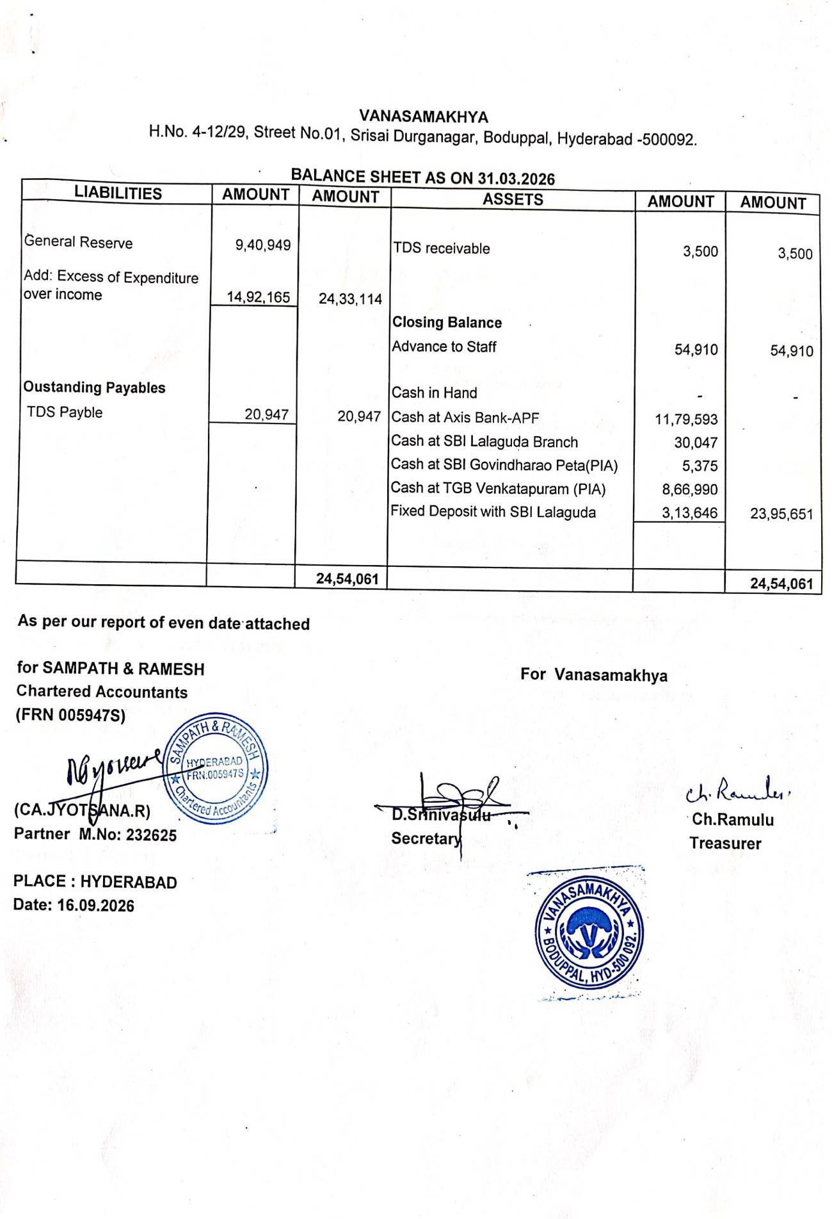
Balance Sheet as on 31.03.2026

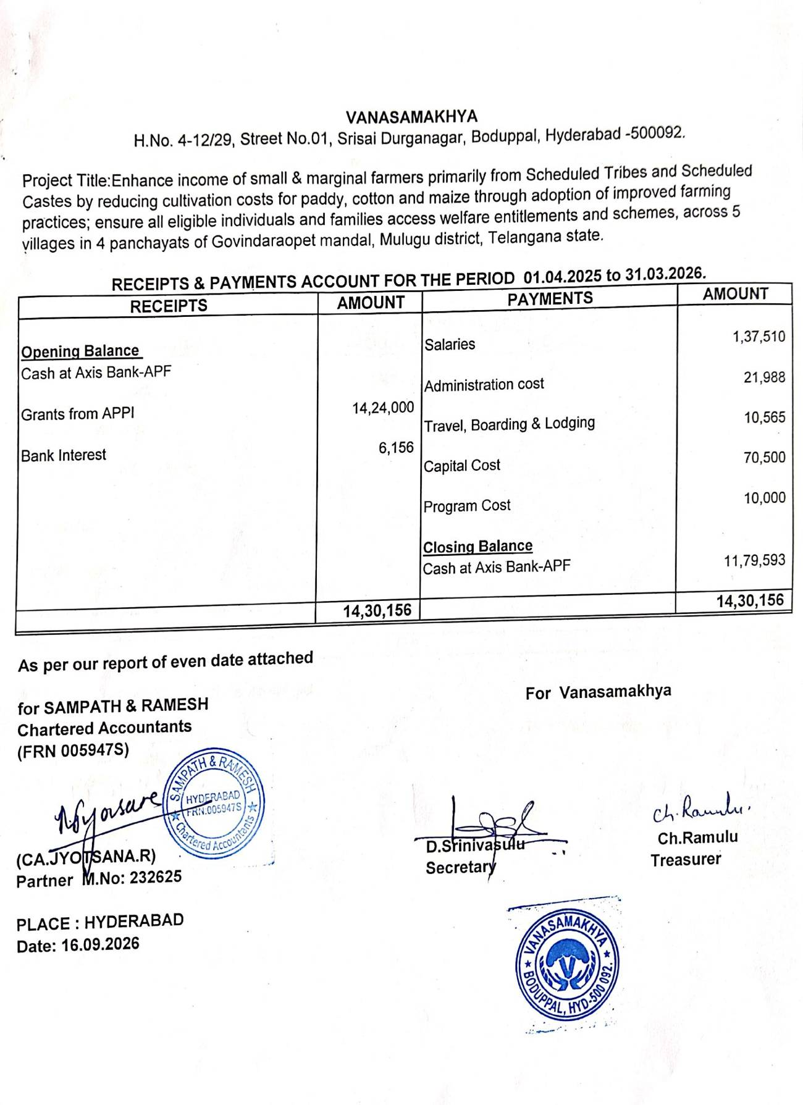
APF Project – Receipts & Payments Account

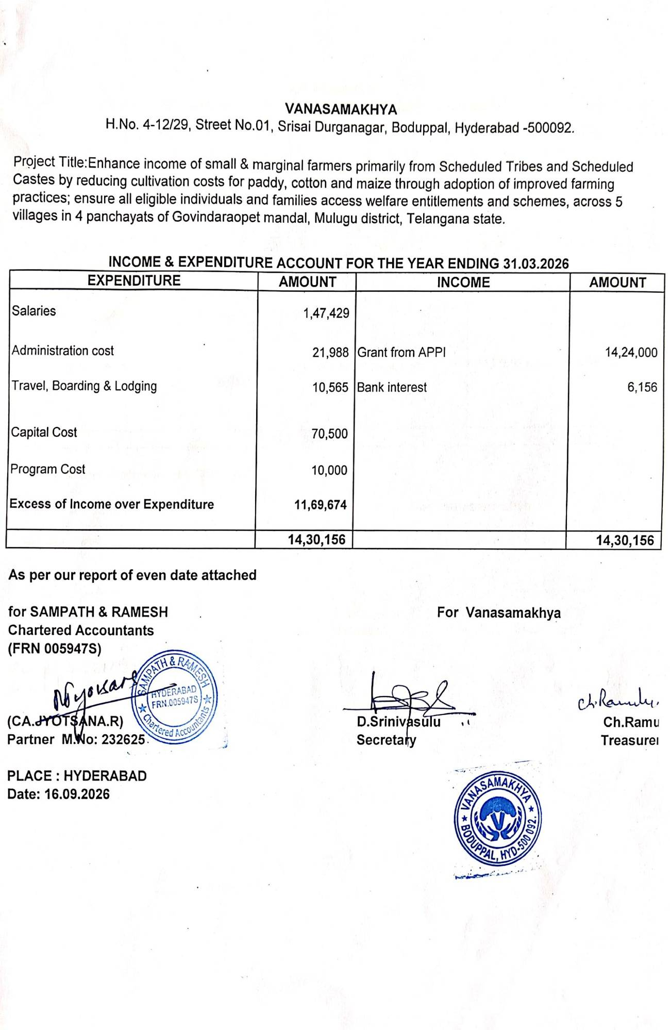
APF Project – Income & Expenditure Account

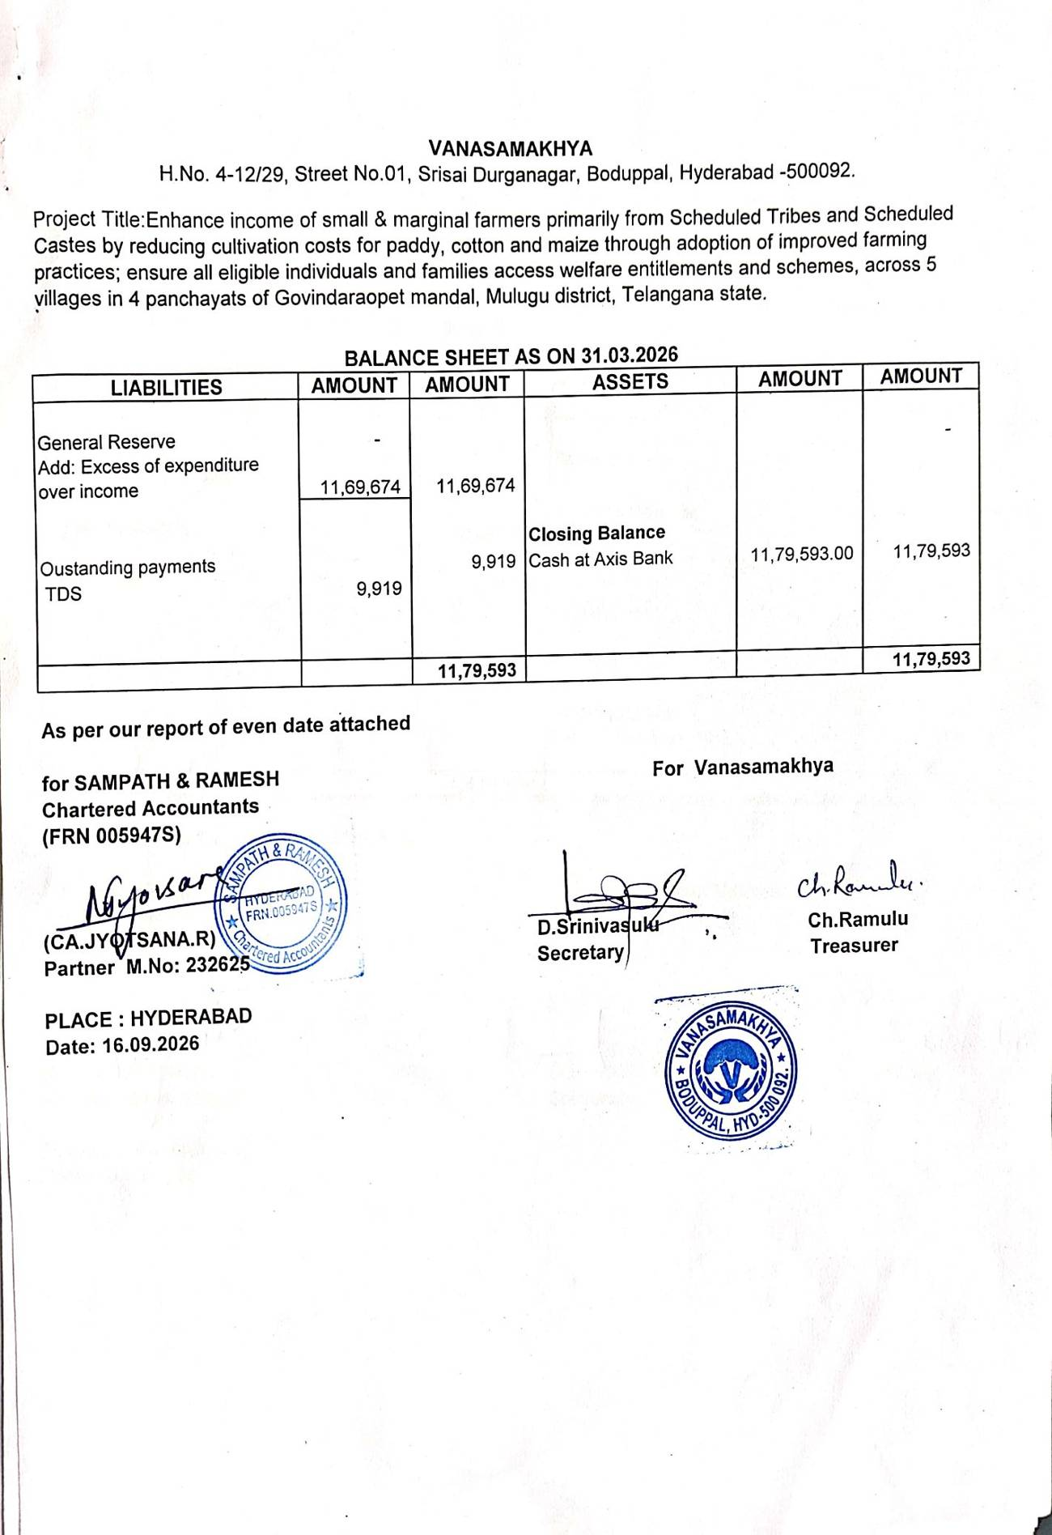
APF Project – Balance Sheet

